Customer: | LERAT |  |  |  | Legend:
Customer Site: | INSTRUMEXPERT |  |  |  | formulas
Instrument Tag Number: | LRC2011 |  |  |  | pick list
 |  |  |  | 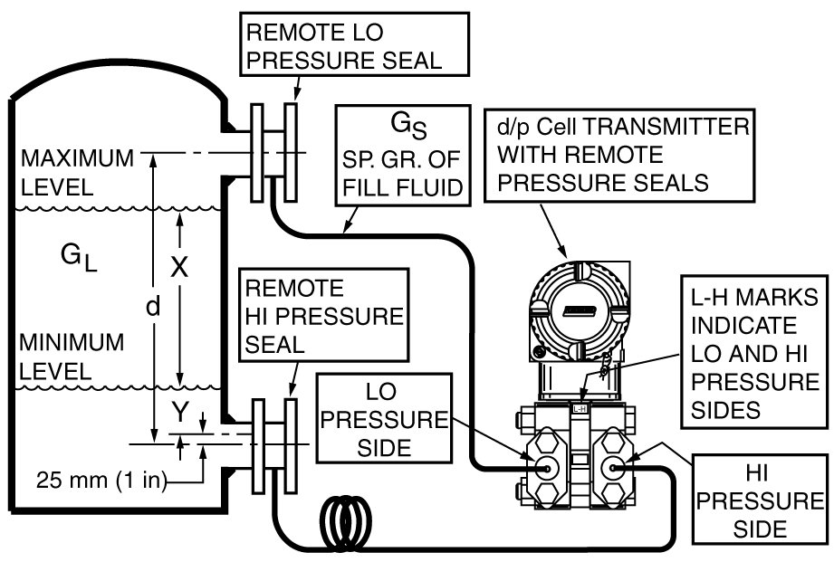 | data entry
Pressure and Level Measurement Using an IASPT DP Transmitter With Pressure Seal(s)
Determine calibrated range (for level) and estimate performance
 | EGU | Distance | Temp.
Measurement Engineering Units | mbar | mm | Deg C
Measurement Range Data
Application | Level, Closed Tank
Liquid Level Span, X | 2650 | mm
Liquid Level Offset, Y | 0 | mm |  | Legend:
Vertical distance between seals, d, | 2650 | mm |  | formulas
Nominal specific gravity of meas. Fluid, G_{L} | 0.68 |  |  | pick list
Specific gravity of seal fill fluid, G_{S} | 0.9072 |  |  | data entry
Process Temperature Range, deg C | High side | Low Side
Maximum | 20 | 20
Normal | 20 | 20
Minimum | 20 | 20
Ambient Temperature Range, deg C | High side | Low Side
Maximum | 40 | 40
Normal (or temp. when xmtr is zeroed) | 10 | 10
Minimum | -35 | -35
Configuration
 | High side | Low Side | Seal Type and Size |  | pss_2a-1z11a_a.pdf |  |  |  |  | Dimensional Print
Capillary Length, ft | 0 | 25 | High side | PSFLT-.3, Flush 3" direct conn. Flange mount seal |  |  |  |  |  | dp_020-342_b.pdf
Fill Fluid | DC200, 3CST |  | PIC W35FF, Flush Mount seal for 3" flange connection, direct connected to IDP10, IGP20
Capillary Internal Diameter, inches | 0.027
Transmitter | IDP10
Span Code | D |  |  |  |  |  |  |  |  | Dimensional Print
 |  |  | Low side | PSFPS-.3, 3" Flush mount (pancake) remote seal |  |  |  |  |  | dp_020-343_b.pdf
 |  |  | PIC W35FP, Flush Pancake (paddle) seal for 3" flange connection. Previously known as the MP type seal. Best price/performance selection.
Results Below
The minimum process pressure must be above the fill fluids vapor pressure at the maximum temperature. | Fluid Vapor pressure @ max. temp. |  |  |  |  |  | Legend: |  | Linls to Dimensional Prints
 | 0.03310 | mm Hg, abs. |  |  |  |  | formulas |  | dp_020-342_b.pdf
 |  |  |  |  |  |  | pick list |  | dp_020-343_b.pdf
 |  |  |  |  |  |  | data entry |  | dp_020-345_a.pdf
 | Calibrated Range: |  | 8400 |  | in H2O |  |  |  | dp_020-346_a.pdf
Notes: | H_{W} @ min. level, or LRV, |  | mbar | -235.30434 | -94.648819 |  |  |  | dp_020-347_a.pdf
Estimates are for 316ss diaphragms - other materials may have ambient and process temp. errors as much as 3X greater. | H_{W} @ max. level, or URV, |  | mbar | -58.929835 | -23.703937 |  |  |  | dp_020-348_a.pdf
 |  |  |  |  |  |  |  |  | dp_020-349_a.pdf
 | Performance Estimates: |  |  |  |  |  |  |  | dp_020-350_a.pdf
 | Temperature effects from normal process and ambient temperatues |  |  |  |  |  |  |  | dp_020-351_a.pdf
 | to the respective maximum and minimum temperatures.
 | Process Temp. Effect |  | Ambient Temp. Effect |  | Head Effect for G_{S} |  | Total Seal SystemTemp. Effect |  | Tolerance of Estimate*
 | for given temp. range |  | for given temp. range |  | chg. over distance d
 | mbar | % of Span | mbar | % of Span | mbar | % of Span | mbar | % of Span | +/- | mbar
To Max. Temp | 0.00 | 0.00 | -0.87 | -0.49 | 8.40 | 4.76 | 7.53 | 4.27 | 0.24
To Min. Temp | 0.00 | 0.00 | 1.30 | 0.74 | -12.61 | -7.15 | -11.30 | -6.41 | 0.35
 | * Tolarance for process and ambient temp. effects due to residual variation in seal characteristics.
 | Response Time Estimates:
Response values are calculated using nominal values for capillary ID and fluid viscosity. Actual times could be as much as 2 X greater or 1/2 X less than shown because of tolerances for capillary ID & viscosity | Ambient Temp, deg C |  |  | -35 | 10 | 40
 | 90% response time, seconds |  |  | 0.31 | 0.09 | 0.05
 | Time constant, seconds |  |  | 0.13 | 0.04 | 0.02
